Materials recommended for Sra. Reyes’ classes:
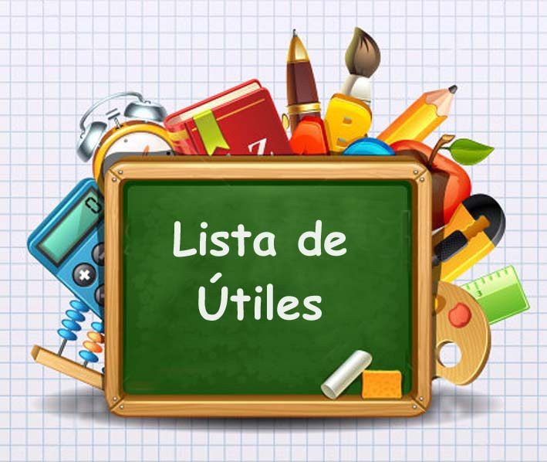
- 1 to 2” binder (only for this class)
- “Marble”/1-subject composition book
- Loose-leaf paper to use throughout class this semester
- Pens for tests and compositions (darker colors are easier to read)
- Pencils for classwork/rough drafts
- Dividers (five pack)
- Spanish-English dictionary for home (and/or class)
- Index cards for vocabulary/notes
- Markers & colored pencils & Highlighters
- Glue stick

**Hand sanitizer and tissue are needed as well!

Special Request!!
*Our students need a wide variety of supplies in order to make the hands-on learning and projects a reality. Gracias!

**Art materials and supplies (paint, modeling clay, Popsicle sticks, brads, clear hot sticks, stickers, duck-tape, play-doh, pipe cleaners, etc.)

Materials recommended for Sra. Reyes’ classes:
- 1 to 2” binder (only for this class)
- “Marble”/1-subject composition book
- Loose-leaf paper to use throughout class this semester
- Pens for tests and compositions (darker colors are easier to read)
- Pencils for classwork/rough drafts
- Dividers (five pack)
- Spanish-English dictionary for home (and/or class)
- Index cards for vocabulary/notes
- Markers & colored pencils & Highlighters
- Glue stick

**Hand sanitizer and tissue are needed as well!

Special Request!!
*Our students need a wide variety of supplies in order to make the hands-on learning and projects a reality. Gracias!

**Art materials and supplies (paint, modeling clay, Popsicle sticks, brads, clear hot sticks, stickers, duck-tape, play-doh, pipe cleaners, etc.)

